You are tasked with implementing a CLI that will identify all NPM dependencies at a given level.

Detailed requirements:
- The CLI can be implemented either in Node.js or Java.
- The logic that calculates the level dependencies is provided. See further details below.
- The CLI should parse a package.json.lock (see official specification) file and print all the dependencies at a specific level in the dependency tree. The dependencies can’t be calculated if the lock file is not available.
- The command-line utility name is “dlevel”
- The CLI arguments are:
- Folder path that holds the package.json.lock “--path”
  - Default: the current folder
  - If the path is unavailable print an informative message
- Level of dependencies to print “--level”
  - Default: print all the root package dependencies.
- Possible “--level” values:
- n < 0: error, print informative message
- n = 0 print the root package name & version
- n > max depth of dependency tree: print informative message
- 0 < n =< max depth of dependency tree: print all the dependencies at that level.
- Output examples can be found on the next pages
- Example package.json.lock is attached

What are you evaluated on:
- Submit source code + clear instructions on how to run it
- Accuracy of results
- Code quality and readability
- Smart usage of OS packages
- Added CLI look & feel/common functionality (for example using exit codes)- bonus

Calculating level dependencies logic
- Java:
  - The jar lock-level-parser-1.0.1.jar is attached.
  - The class DependencyLevelCalculator should be initiated with the full path of the lock file.
  - The getLevelDependencies() method calculates the entire dependency hierarchy tree and returns a map. The map entry key is an integer and represents the level of the hierarchy and the entry value for each such key is a list of all the dependencies for a given level.
  - The method printLevelDependencies() is mostly for debugging purposes. It gets the map returned by the getLevelDependencies() method as an input and prints the dependencies in all levels.
  - Example invocation:
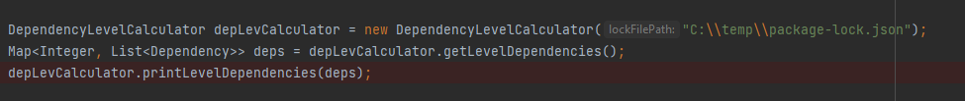
  - Example output of the printLevelDependencies() method
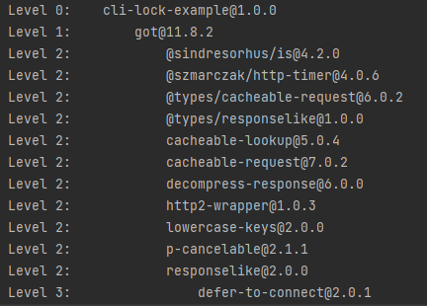
- Node.js
  - The dependency_parser.js file is attached
  - The function getLevelDependencies() calculates the entire dependency hierarchy tree and returns a map. The map entry key is an integer and represents the level of the hierarchy and the entry value for each such key is a list of all the dependencies for a given level. The input to this function is the full path of the lock file.
  - The function printLevelDependencies() is mostly for debugging purposes. It prints the dependencies at all levels.
  - Example invocation
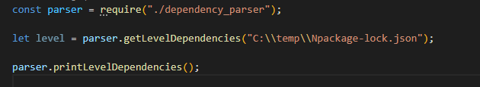
  - Example output of the printLevelDependencies() function can be seen in sub section f of the Java section.

Examples based on the provided package.json.lock file:
- Command:
“dlevel --level 0”
Output:
cli-lock-example@1.0.0
- Command:
“dlevel --level 1”
Output:
got@11.8.2

- Command:
“dlevel --level 2”
Output:
@sindresorhus/is@4.2.0
@szmarczak/http-timer@4.0.6
@types/cacheable-request@6.0.2
@types/responselike@1.0.0
cacheable-lookup@5.0.4
cacheable-request@7.0.2
decompress-response@6.0.0
http2-wrapper@1.0.3
lowercase-keys@2.0.0
p-cancelable@2.1.1
responselike@2.0.0

